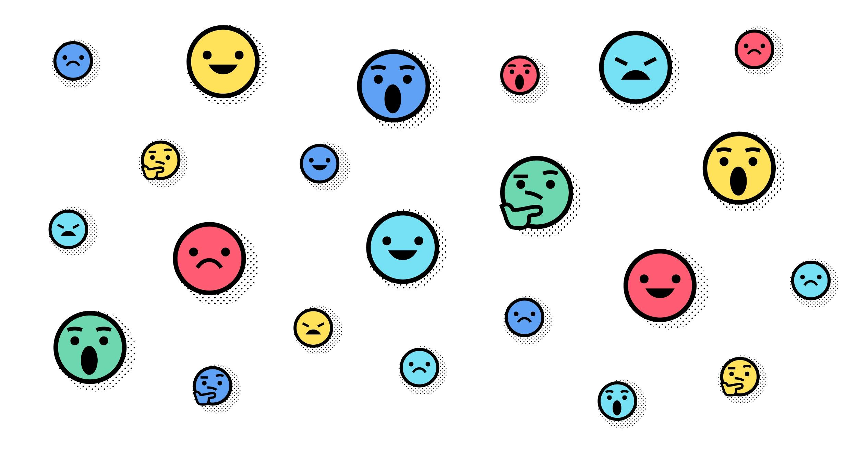

2018 Internet Health Report

What is the Internet Health Report?
The Internet Health Report is Mozilla’s open source initiative to document and explain what’s happening to the health of the internet

2017 has been called a ”terrible year for tech” by some. Headlines about troubling aspects of the internet have been everywhere. But people around the world are also saying things, teaching things and building things to tackle these challenges. More people are opening their eyes every day to the impact the internet has on our societies, economies and personal well-being. We are beginning to see the health of the Internet as not just a technical issue, but a human one. The Internet Health Report aims to connect the dots and look for patterns between often siloed issues—to look at the human experience of the internet as a whole.
The report features global insights and perspectives across five issues: Privacy and Security, Openness, Digital Inclusion, Web Literacy and Decentralization.
Read the full report at:
mzl.la/ihr

2018 Internet Health Report

What is the Internet Health Report?
The Internet Health Report is Mozilla’s open source initiative to document and explain what’s happening to the health of the internet

2017 has been called a ”terrible year for tech” by some. Headlines about troubling aspects of the internet have been everywhere. But people around the world are also saying things, teaching things and building things to tackle these challenges. More people are opening their eyes every day to the impact the internet has on our societies, economies and personal well-being. We are beginning to see the health of the Internet as not just a technical issue, but a human one. The Internet Health Report aims to connect the dots and look for patterns between often siloed issues—to look at the human experience of the internet as a whole.
The report features global insights and perspectives across five issues: Privacy and Security, Openness, Digital Inclusion, Web Literacy and Decentralization.
Read the full report at:
mzl.la/ihr

2018 Internet Health Report

What is the Internet Health Report?
The Internet Health Report is Mozilla’s open source initiative to document and explain what’s happening to the health of the internet

2017 has been called a ”terrible year for tech” by some. Headlines about troubling aspects of the internet have been everywhere. But people around the world are also saying things, teaching things and building things to tackle these challenges. More people are opening their eyes every day to the impact the internet has on our societies, economies and personal well-being. We are beginning to see the health of the Internet as not just a technical issue, but a human one. The Internet Health Report aims to connect the dots and look for patterns between often siloed issues—to look at the human experience of the internet as a whole.
The report features global insights and perspectives across five issues: Privacy and Security, Openness, Digital Inclusion, Web Literacy and Decentralization.
Read the full report at:
mzl.la/ihr

